An activator inhibitor cellular automaton is a system of cells following a set of rules that updates each cell asynchronously based on two interaction range values, two interaction strength values, and a bias value. In implementing an AICA, these values were taken on the command line and used to update the AICA until the system converged to an unchanging state; this state was then used to measure correlation, the extent to which the states of cells at various distances are correlated with each other, correlation length, the measure of how quickly special correlation decreases with distance, and mutual information, the measure of the degree to which two sources are not independent. For each combination of J1 and J2 (interaction strengths), R1 and R2 (interaction ranges), and h (bias), the program was iterated five times and the measurable values were averaged in attempt to create a better overall representation of the system. In this report I will analyze how different interaction ranges, interaction strengths, and biases affect the pattern produced by an AICA and how correlation, correlation length, and mutual information represent these changes.

First, I analyzed an experiment system with the first interaction strength (J1) set to 1, the second interaction strength (J2) set to -0.1, and varying values for interaction ranges (R1 and R2) and bias (h). I ran thirty-eight trials and first took notes regarding the visual differences between groups of trials that held the same interaction ranges and changed bias. Analysis within these groups displayed the effects of bias, while analysis between different groups displayed differences between interaction groups.

The first group I analyzed, trials two through six, saw extreme influence in bias. These trials held R1 = 1 and R2 = 5, while iterating h from -4 to 4 in increments of 2. 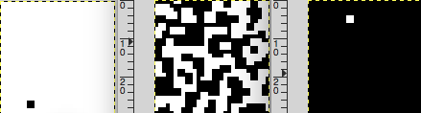

As seen above, only trial 4 (middle image, with a bias of 0) displays an interesting pattern while the other two trials (2: on the left with bias -4, 6: on right with bias 4) are dominated by either dead or live states. Not pictured, trial 3, with a bias of -2, appears mostly white with some black patches and trial 5, with a bias of 2, appears mostly black with some white patches. With these somewhat low interaction radius ranges, it appears that bias greatly affects the outcome of the trial. With these basic visual observations, I next looked to graph the differences between the correlation, joint entropy, and mutual information.

Surprisingly, trial 4 saw the lowest correlation out of these three trials. I suppose that since the other trials had mostly the same state, they came out with a higher correlation. The correlation length for trial 2 was 4 cells; the correlation length for trial 4 was 1 cell; the correlation length for trial 6 was 4 cells. Joint entropy was certainly highest in trial 4, which makes sense, as it is the only trial that had much variance in the overall cell states. Mutual info was much higher in trial 4. At this point, I began to doubt the overall usefulness of comparing mostly dead states with a lively state, but I did gather than an overall connection between smaller radii perhaps leading to increased emphasis on bias to determine the final form of the system.

Next, to highlight a difference in R2, I analyzed the group of trials ranging from 12 to 16, where R1 was set to 1 and R2 was set to 14. I decided to focus my attention on trial 13, 14, and 15 since the h values, -3, 0, and 3 respectively, closely resembled the last group of trials I analyzed. Visually, the difference is apparent; an interweaving pattern is apparent, but all three of these trials appear vary similar, in contrast to the prior group’s vastly different appearance depending on bias.  
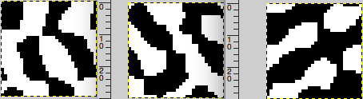

Unsurprisingly, the graphs of these three trials appear very similar; their correlation, joint entropy, and mutual information seem to match very close for each distance. Each trial had a correlation length of 2, showing despite its greatly increased range the stronger J1 value overpowered the J2 value for correlation. Correlation, joint entropy, and mutual info were all nearly identical, displayed below in their respective graphs.

Next, I compared the values of this group with the best representative from the prior group, trial 4. The increased R2, from 5 to 14, unsurprisingly increased the correlation length from the first group to the second. Correlation in trial 14 maintains a higher value for much higher distance than trial 4. The joint entropy values are somewhat similar for these two trials, but the values of mutual information are higher at lower distances in trial 14 while higher and higher distances in trial 4.

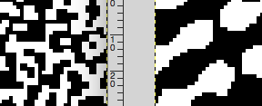

Visually, it is apparent that trial 4 has much thinner, more frequent designs while trial 14 has thicker patterns. Based on this, it is possible that the closer correlation caused by the closer R2 value caused trial 4 to have more patterns with smaller diameter than the larger R2 valued trial 14.

I then looked to a larger R1 value with a relatively similar R2 value; the group of trials 30 through 32 held R1 equal to 7 and R2 equal to 9. Trial 30 was uninteresting, every iteration of it would always find its way to a solid state of either black or white cells; it’s joint entropy and mutual information were zero corresponding to this. Trial 31 had three iterations of cell states lead to solid colors of black and white, but its one interesting result was essentially a straight line dividing the iteration into roughly half black and half white. Similarly, trial 32 had two iterations lead to the cell states composing a solid color and two iterations leading to a single white stripe of roughly forty percent of the total area. In these trials, the correlation length in the useful iterations of the trial came out to be 4 and 5, representing trials 31 and 32 respectively. This actively displaces the greater interaction distance values resulting in correlation values appearing at higher distances, an expected result.

After looking through these differing values in interaction ranges and biases, a few conjectures became apparent. First, bias appeared much more prevalent at smaller interaction ranges; the trials with low interaction ranges and opposite biases seemed to mirror each other. Conversely, when the interaction range for R2 was increased while keeping R1 the same, the bias barely seemed to affect the trials. In this case, the correlation distance, joint entropy, and mutual information remained the same for all the varying biases and the final state of the AICAs seemed very similar, perhaps showing that a larger number between R1 and R2 results in the bias mattering less.

In a different experiment, the AICA reinitialized the interaction strengths to completely ignore J2 by initializing it to zero, while maintaining J1 equal to 1. In these trials, R2 is irrelevant since it only measures the effects of J2; therefore the systems are based only on R1 and h. In each trial, there were iterations where the entire system would go to a single state; I picked out the interesting outlying cases to be pictured below.

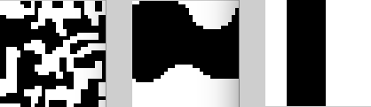

On the left is trial 1, R1’s value is set to 1 and the bias is set to -1; on the middle is trial 2, R1’s value is set to 3 and bias is set to -1; on the right is trial 3, R1’s value is set to 6 and bias is set to -2. My conjecture is the only thing keeping these systems from going to a steady state quickly is their negative bias; I created an experiment quickly with a positive bias to see each system very quickly iterate to a solid +1 state. In the above examples, the correlation length unsurprisingly increases along with the interaction distance, from 2 in trial 1 to 3 in trial 2 to 4 in trial 3. Trial 1 is the only trial that successfully produced a unique system each time, so I decided to compare it against a similar trial from the prior experiment before J2 excluded; I decided on trial 4 from these experiments (graph appears above on page 3 and is copies below).

The graphs look very similar, so I decided to compare them visually while comparing individual values for correlation, mutual information, and joint entropy.

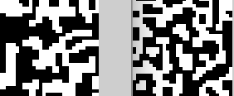

On the left is trial 1, J1 = 1, J2 = 0, R1 = 1, R2 is irrelevant, and h = -1; on the right is trial 4, J1 = 1, J2 = -0.1, R1 = 1, R2 = 5, and h = 0. Despite these differences, they have similar patterns. Trial 1’s patterns have slightly larger radii, which are displayed in correlation length’s value equaling 2 rather than trial 4’s correlation length equaling 1. Joint entropy and mutual information have similar values.

In these trials, the only way to get interesting behavior is to balance interaction range with a negative bias. Even with these parameters, it appears much more likely to lead to a stable, single color state.

Next, I examined a system where J1 = 0, J2 = -.1, and R1, R2, and bias were changed. Patterns appeared much more frequently than when J1 was zeroed, which came as something of a surprise to me. In the first trial, R1 = 1, R2 = 2, and bias = 0; every iteration of the system quickly went to a solid state. I decided to compare my trial 5, with R2’s value equal to 6 and bias equal to 0, to trial 6, with R2’s value equal to 9 and bias equal to 0 to compare the difference between different R2 ranges. Both trials maintained an R1 value of 1, so the radius difference differed by 3. 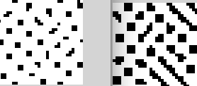

On the left is trial 5, on the right is trial 6. The increased R2 radius has the obvious effect of increasing the size of the spots, while also creating a few stripe structures. Despite these similar structures, the correlation length in trial 5 is strongest at eleven, compared to the correlation length in trial 6 being strongest at a distance of one. When looking at all the correlation distance data in trial 6, correlation is higher at eleven than its surrounding values, but not as strong as at one, so despite the discrepancy, there is some consistency. The joint entropy and mutual information are higher at every single distance index in experiment 6, representing the different patterns.

Throughout these trials, it is apparent that increased R2 radii increases the size of the spots and complexity of the patterns that occur, while increasing joint entropy and mutual information more than correlation.

Overall, it is clear these different parameters affect the patterns produced by activation inhibition cellular automata profoundly. When maintaining values for both activation and inhibition strengths, a stronger correlation seems to inspire larger stripes. Additionally, bias appears to color of the system much more when the interaction radii are much smaller. When disabling the inhibition strength, the system must be balanced between the activation range and a negative bias. Finally, when activation strength is disabled, the range of the radius of the inhibition appears to directly affect the size and complexity of the structures appearing.